LAP User Manual

**Load Analysis Program** (LAP) is a MATLAB graphical user interface that can compute a variety of kinetic and kinetic symmetry outcomes from data collected using the single sensor loadsol®, a wireless and relatively inexpensive force sensing shoe insole that has been validated against gold-standard force plates (Peebles et. al *Sensors* 2018). This program was designed to provide users with an easy method to assess kinetic and kinetic symmetry during walking, running, squatting, hopping, and bilateral landing tasks.

**Table of Contents**

**System requirements** 1

**QuickStart instructions** 1

**Detailed instructions** 2

**Guided tutorials** 9

Walking 18

Squatting 20

# **For Questions Contact**

Alex Peebles [apeebles@vt.edu](mailto:apeebles@vt.edu)

Adam Luftglass [adluft@vt.edu](mailto:adluft@vt.edu)

# **System requirements**

This version of LAP has been tested on MATLAB version r2019b – r2020a, and will likely work with any newer version.

# **QuickStart Instructions**

If you are new to loadsol® skip the QuickStart instructions. To start, go to <https://github.com/GranataLab/LAP> and download all of the files as a zip file by clicking “Clone” then “Download Zip” and click on “Extract All” extract the “Lap-Master” folder into the desired folder on your computer. Then, open and run the loadsol_analysis MATLAB Code file in MATLAB. Click the “Load data” button to open new files, enter the participants bodyweight (Newtons) to normalize outcomes by bodyweight (N), select which task the data corresponds to, delete unwanted initial contact or toe off indices, adjust calculation parameters if desired, and click compute. LAP will format all outcomes into a table that will be automatically written to a user-specified excel workbook.

# **Detailed Instructions**

Below is the figure presented when processing a bilateral drop jump task using LAP. Labels are explained in pages 3-7.

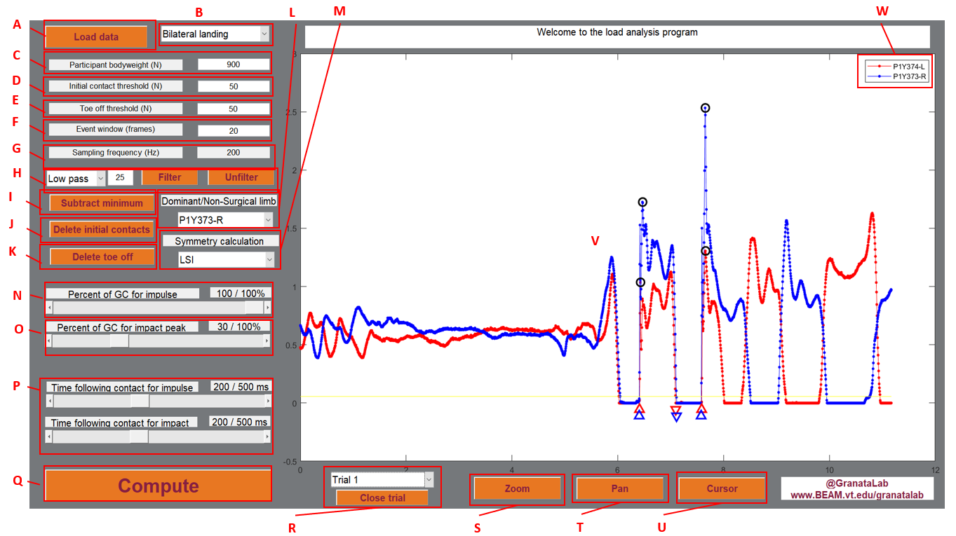

**Letters below correspond to diagram on Page 2**

**A: Open new file**

Clicking “Load data” will prompt you to navigate to and open loadsol® file(s) (.txt) for analysis.

**B: Task Selection**

There are four types of tasks that LAP can analyze: Bilateral Landing, Unilateral Landing, Gait, and Squatting. After loading data (or at least before clicking compute), select the appropriate tasks to ensure that outcomes are computed appropriately (see the Guided Tutorials for an explanation of outcome calculations).

**C: Participant Body Weight**

Entering the participant’s bodyweight in Newtons here will normalize the plotted data and compute outcomes as follows: plantar force (N) / bodyweight (N) = plantar force (%bodyweight).

**D-F: Initial Contact Threshold, Toe Off Threshold, and Event Window**

LAP identifies initial contact when plantar force crosses above, and remains above, the initial contact threshold for a specified time window, and toe off when plantar force crosses below, and remains below, the toe off threshold for a specified time window (See Figure Below). Initial contact and toe off indices are plotted with upward and downward arrows, respectively, separately for the left and right limbs. The default setting for the initial contact and toe off thresholds is 50 Newtons, and the default time window is 20 frames. However, these values can be changed if desired (e.g. if data is noisy and events are misidentified). Changing either the initial contact threshold, toe off threshold, or time window will erase and re-identify all events. The initial contact and toe off threshold are plotted in cyan and yellow, respectively. Note that if threshold values are the same (e.g. for default settings), only the toe off threshold will be visible.

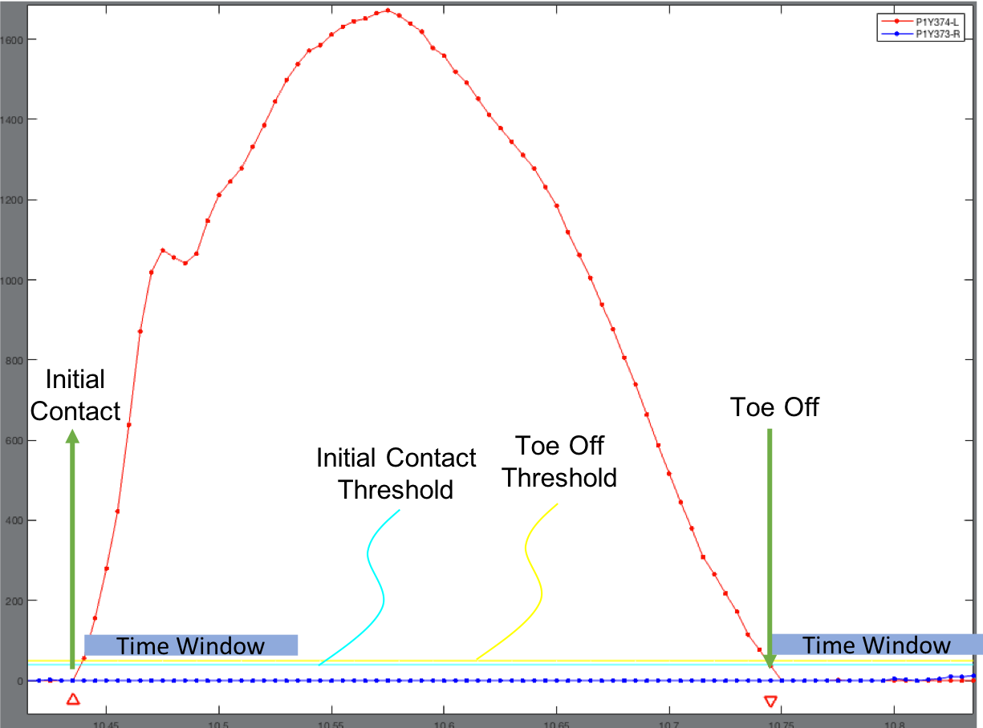

**G: Sampling Frequency**

LAP displays the data collection sampling frequency (in Hz) automatically determined by LAP based on the data file.

**H: Filtering Options**

This section allows the user to either low- or high-pass filter the raw force data with a user-specified cutoff frequency (entered to the right of the drop-down menu). Note that in our lab we typically do not filter our loadsol® data. However, we wanted to allow users to low-pass filter data if unwanted high-frequency noise is present, or high-pass filter data if low-frequency drift is present. Clicking unfilter will remove the applied filter.

**I: Subtract Minimum**

If drift is present and the plantar force does not go to zero during the swing phase, clicking subtract minimum will subtract the left and right plantar force by the lowest force measured in the left and right sensors, respectively, for each trial.

**J and K: Delete Initial Contacts and Delete Toe Offs**

Clicking these buttons allows the user to delete unwanted initial contact (Upward Arrows) and toe off (Downward Arrows) events (e.g. if unwanted steps are recorded after a trial). After clicking Delete Initial Contacts (or Toe Offs), a crosshair will appear on the plot, and users are prompted to click on each unwanted initial contact (or toe off). Note that only the vertical line of the crosshair is used to delete events, and the closest event to each click is removed, so there is no need to be exact when clicking on an unwanted event. Please see the guided tutorial for examples on how this process works.

**L: Dominant Limb Determination**

The user is encouraged to enter the participant’s dominant limb, which is used for symmetry calculations. For a patient population, the non-surgical limb is often considered the dominant limb. In our lab, we typically define the dominant limb of a healthy uninjured participant as the limb with which they choose to kick a soccer ball with.

**M: Symmetry Calculation**

LAP allows the user to evaluate symmetry of computed outcomes (i.e. compare outcomes between the dominant (D) and non-dominant (ND) limbs) using either the Limb Symmetry Index (LSI), Asymmetry Index (ASI), or Normalized Symmetry Index (NSI) (see Equations below). The LSI ranges from 0 to infinity, with 100% reflecting perfect symmetry and values less than 100% reflecting that load was greatest in the dominant limb. The ASI ranges from 0-100%, with 0% reflecting perfect symmetry and values approaching 100% reflecting asymmetry (with no directionality). The NSI ranges from -100% to 100%, with 0% reflecting perfect symmetry and values above 0% reflecting that load was greatest in the dominant limb. Note that this NSI equation has been reduced from Queen et al. (Journal of Biomechanics, 2020) for kinetic outcomes which will always be positive. As our group strongly believes that symmetry should be evaluated on simultaneous steps during gait or trials/repetitions during bilateral landing or squatting, these symmetry outcomes are computed for each stride/trial/repetition and then averaged across trials. However, as unilateral landings do not occur simultaneously, LAP averages load outcomes across trials for each limb before computing symmetry indices.

; ;

**N and O: Percent of GC (Ground Contact) for Impulse and Impact Peak**

An initial contact followed by a toe off is considered a ground contact phase (or ‘stance phase’). These sliders adjust what percentage of the ground contact phase LAP uses to compute impulse and impact peak (see Figure below). Note that impact peak is defined as the largest *peak* (i.e. not largest *value*) in the specified window, and impulse is defined as the area under the force-time profile in the specified window.

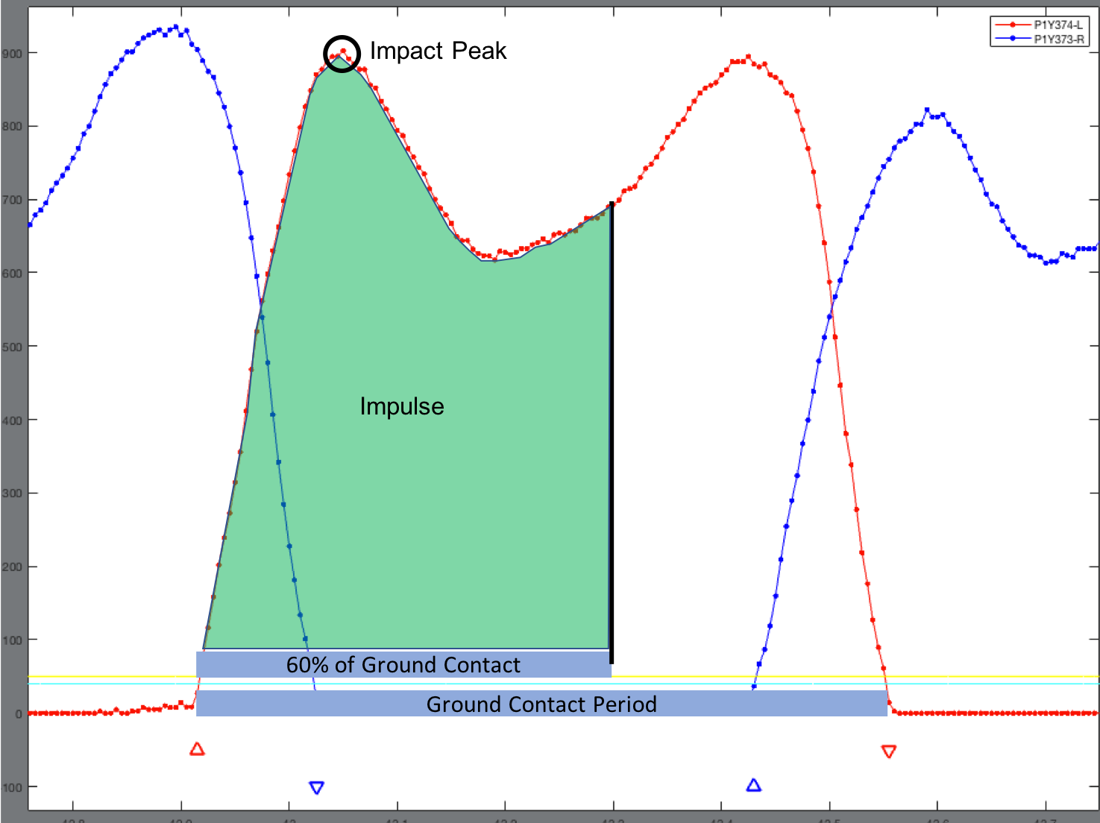

**P: Time Following Contact for Impulse and Impact Peak**

When a ground contact phase is not defined (i.e. an initial contact not followed by a toe off), LAP will compute impact peak and impulse for a fixed time following initial contact, specified by these sliders (see Figure below).

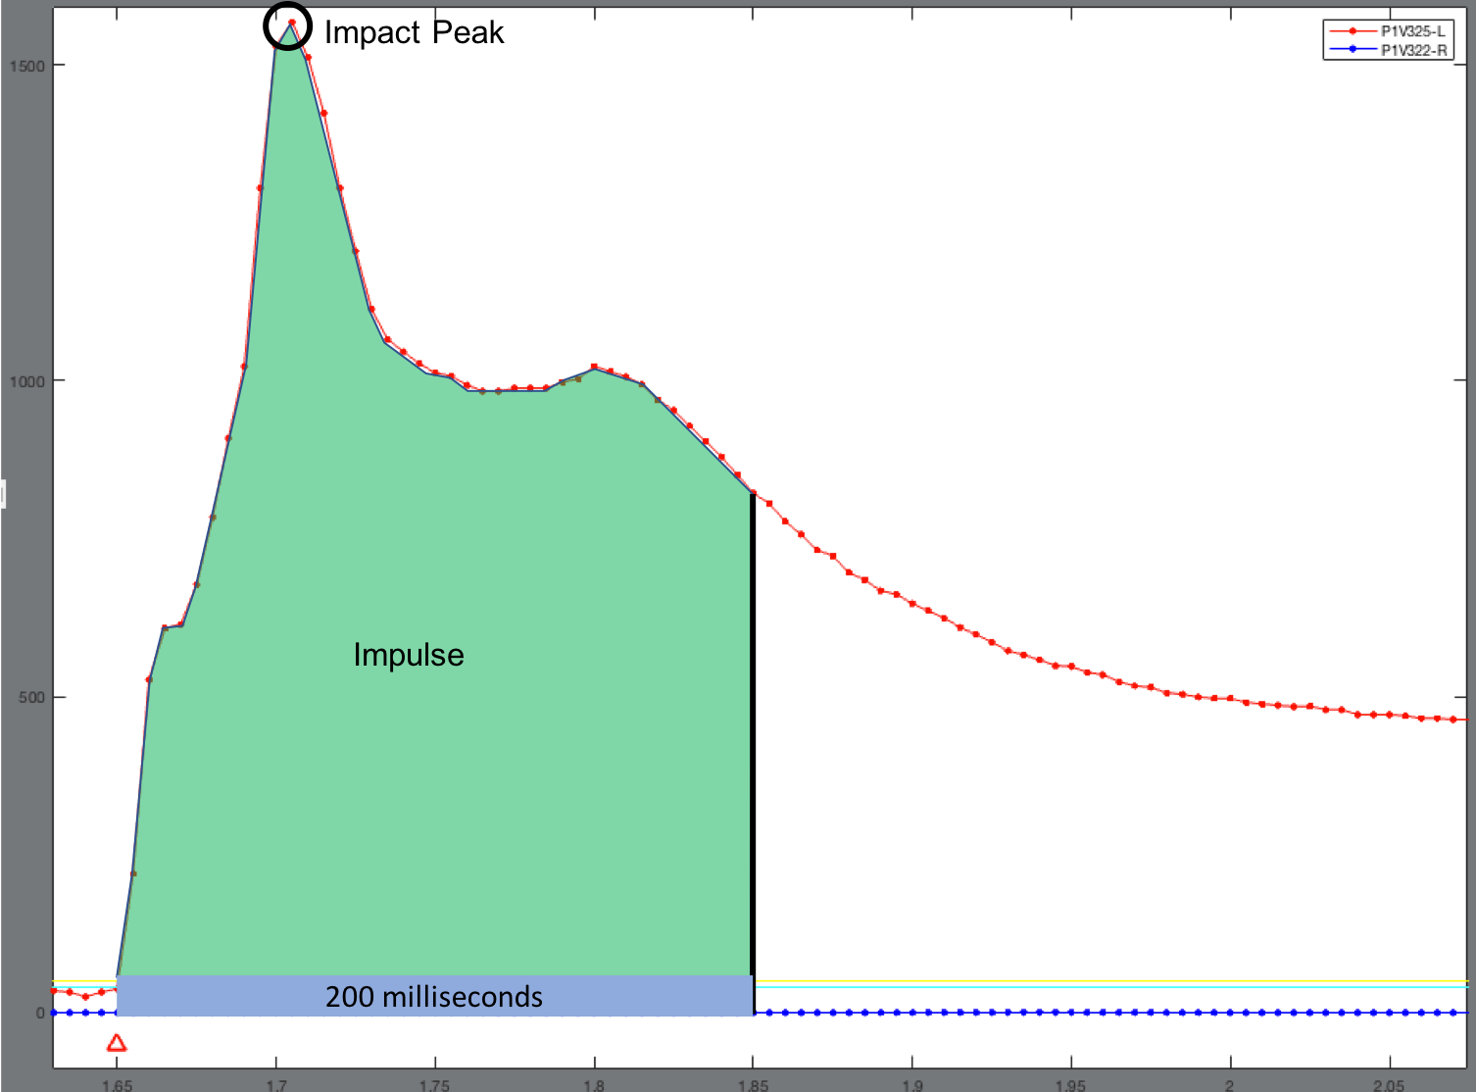

**Q: Compute**

After ensuring that the correct task has been selected (see Section B), all events are appropriately identified (see Sections D-F and J-K), and calculation parameters have been adjusted (see Sections L-Q), clicking the “Compute” button will compute all outcomes and ask the user to save the outcomes in an excel workbook and tab of their choice.

**R: Trial Number and Close Trial**

The user can change which trial is plotted and close trials if desired (e.g. if a data collection/task error was made).

**S: Zoom**

To zoom in on the plots, click the “Zoom” button. Note that double-clicking inside the plot will zoom out.

**T: Pan**

Click the “Pan” button to pan the graphed data.

**U: Cursor**

Clicking on the cursor tool allows you to click on a point, and the value of that point will be displayed.

**V: Plot**

This window is where the plantar force data, identified initial contact and toe off events, and impact peaks will be plotted.

**W: Key**

This section is the key generated by LAP when data is loaded from the loadsol® data

# **Guided Tutorials**

The following tutorials are intended to demonstrate how to use LAP to assess kinetic outcomes from loadsol® data collected during movement tasks which focus on injury prevention in athletics. Note that all data files for these tutorials can be downloaded along with this user manual and the LAP MATLAB code through our GitHub page: <https://github.com/GranataLab/LAP>. For a guide on using and calibrating the loadsol® sensors, see this YouTube video: <https://youtu.be/LMxImTUJBXg>

**Bilateral Landing**

For these trials, a patient following anterior cruciate ligament reconstruction surgery completed a forward bilateral drop vertical jump. The participant began standing on a 31cm box, jumped forward to a landing target placed half of their body height away, landed with both feet, changed their momentum as quickly as possible, jumped vertically as high as possible, and finally landed again with both feet.

**Step 1:** Click “Load Data”, then navigate to and open the files starting with “bi”.

**Step 2:** Enter in the participant bodyweight in Newtons (900 N)

**Step 3:** Make sure the “Bilateral Landing” is selected from the drop-down menu next to “Load Data”.

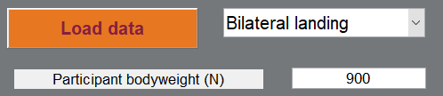

**Step 4:** Click the “Delete Initial Contacts” button and click on the four initial contacts which follow the second landing (see Figure below – left) and press enter. Then, click the “Delete Toe Offs” button and click on the two toe offs before the first landing and five following the second landing (see Figure below – right).

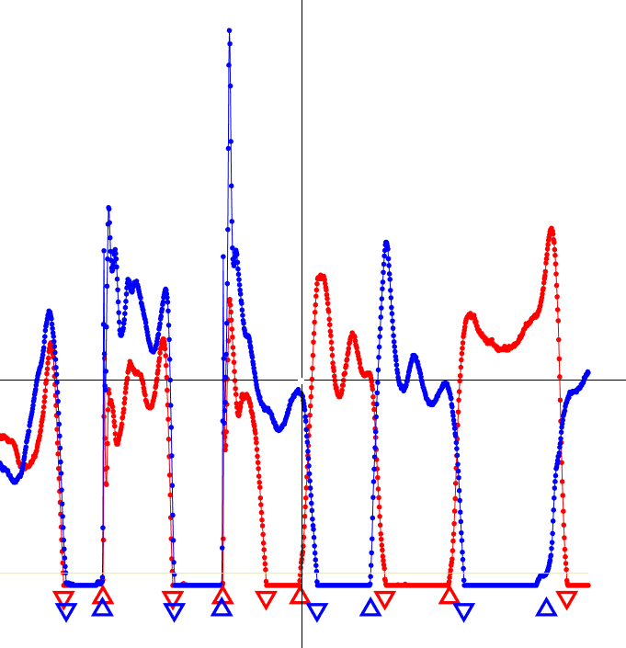 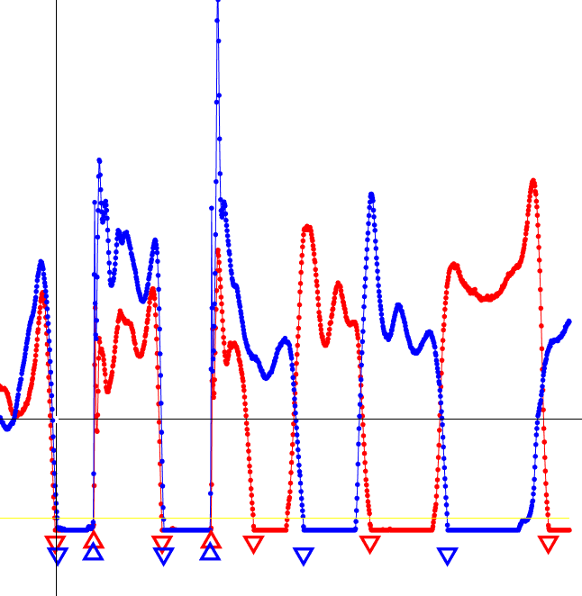

**Step 5:** Select the drop-down menu (Section R above) and select trial 2, repeat step 4, then select trial 3 and repeat step 4 again. After this step, all trials should look as below, with four initial contact (two per limb) and two toe offs identified.

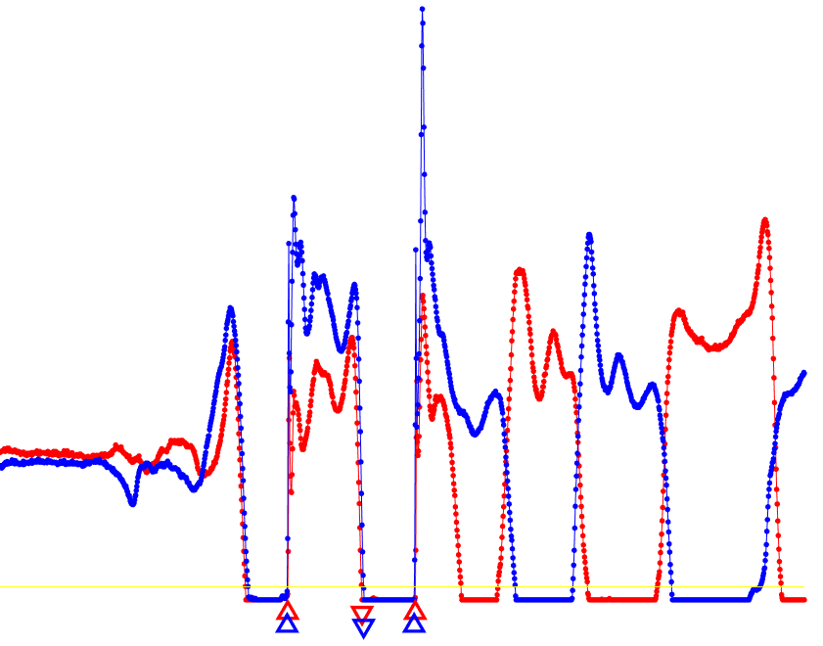

**Step 6:** Select “P1Y373-R”as the dominant (or non-surgical) limb in the drop-down menu.

**Step 7:** Change the symmetry index to NSI.

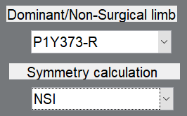

**Step 8:** Set the percent of GC for impulse and impact peak to 100 and 30%, respectively, for the first landing (where initial contacts are followed by toe offs). Set the time following contact for impulse and impact peak to 200 milliseconds for the second landing (see Figure below).

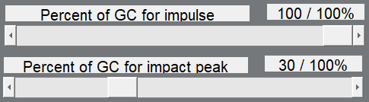 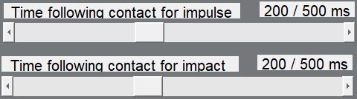

**Step 9:** Click the “Compute” button, select your desired output folder in which to save data, and input a file name (to name the spreadsheet) and condition name (to name the tab where data will be written). We typically save data in the same folder as the raw data, set the file name to the participant ID, and condition name as the movement (e.g. BL for bilateral landing). Notice that black circles have been plotted on each trial to indicate computed impact peaks. A new file has been created which contains all computed outcomes. Note that, in the output file, PIF stands for peak impact force (or impact peak), LR stands for loading rate, and IMP stands for impulse. The symmetry outcome which will always read LSI in these tables is actually the symmetry equation selected in step 7. **Note:** for both bilateral and unilateral landing trials, loading rate is computed as the peak force divided by the time between initial contact and the instant of peak impact force (see Figure below).

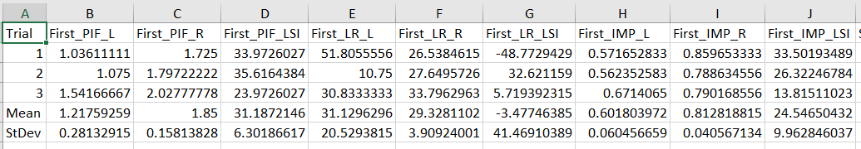

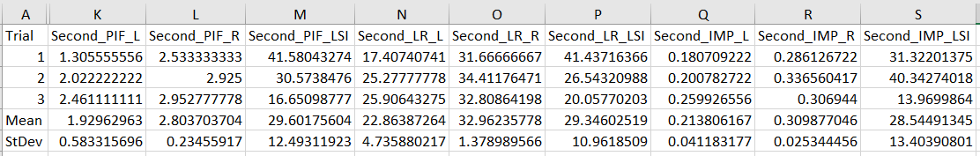

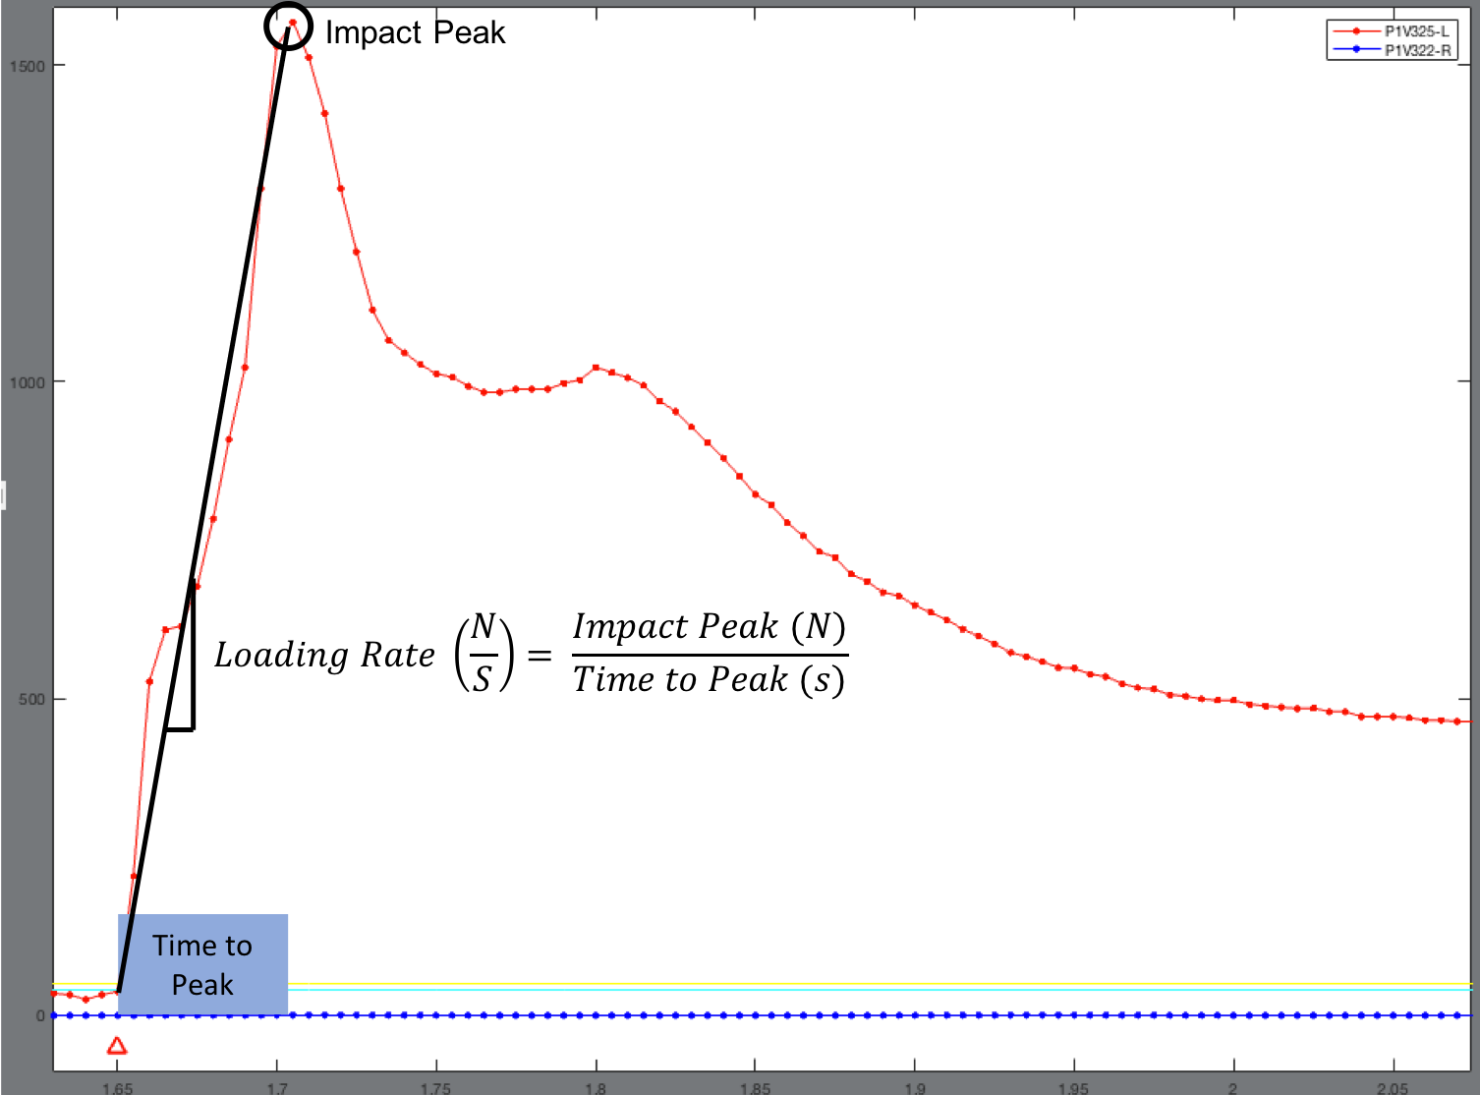

**Unilateral Landing**

For these trials, a healthy participant completed a forward unilateral drop landing. The participant started balancing on one foot on top of the 31 cm high box, dropped straight down, and landed on the same foot.

**Step 1:** Click “Load Data”, then navigate to and open the files starting with “u” (6 files) by selecting all and pressing enter, select “Unilateral Landing” from the drop-down menu, and enter the participants bodyweight (525 N).

**Step 2:** Select “P1V322-R”as the dominant (or non-surgical) limb in the drop-down menu. Then, ensure that the symmetry index is LSI.

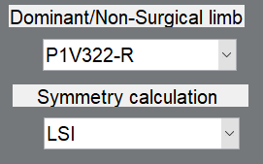

**Step 3:** Set the time following contact for impulse and impact peak to 300 milliseconds for the landing (see Figure below).

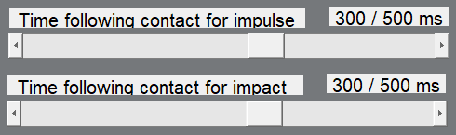

**Step 4:** Click the “Compute” button, select your desired output folder to save data to, and input a file name (to name the workbook) and condition name (to name the tab where data will be written). Lap will automatically add circles around the peaks on the plot.

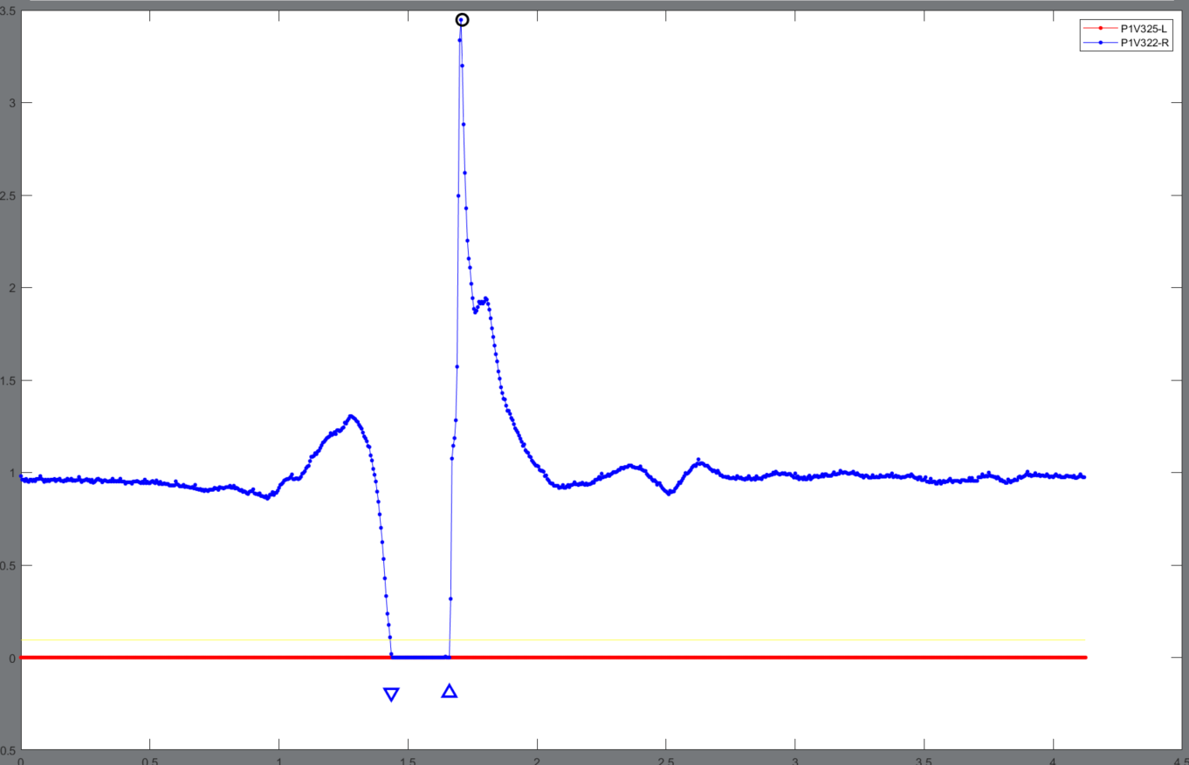

**Step 5:** You can now access the data in the “Lap-Master” folder and see the desired outcomes in the excel file that you saved the data as.

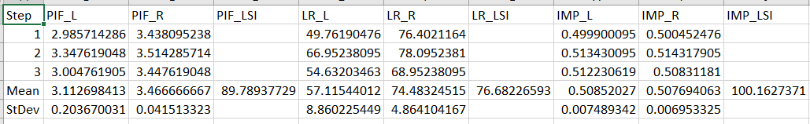

**Running**

For this example, a relatively uninjured participant (author ATP) ran overground at a comfortable pace, back and forth twice in a large room (four passes). We are going to analyze the middle two strides from each pass, where the participant should have reached a steady-state speed.

**Step 1:** Click “Load Data”, then navigate to and open the file named “run_20-05-12 04-18-51-491”, select “Gait” from the drop-down menu, and enter the participants bodyweight (800 N).

**Step 2:** Zoom in on the entire first pass, and click “Delete Initial Contacts”. We are going to keep only the two strides in the middle of each pass (circled in green in Figure below), so click on every upward point arrow besides these four. Click on “Delete Toe Offs” and click on all downward point arrows besides the ones circled. Click on “Delete Initial Contacts”

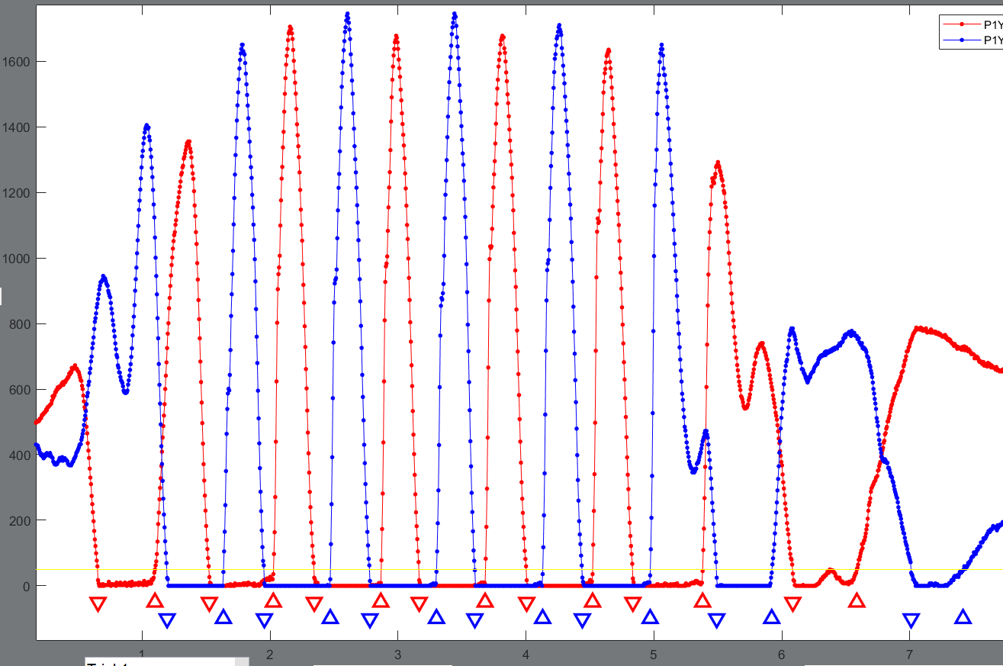

**Step 3:** Repeat Step 2 for the second, third, and fourth pass. After this step, there should be four ground contact phases per pass, and your GUI axes should look like the Figure below (next page).

**Step 4:** Select the right foot as the dominant limb in the drop-down menu by selecting “P1Y373-R”.

**Step 5:** Set the percent ground contact sliders so that impulse and impact peak are set to 100%.

**Step 6:** Click the “Compute” button and save data in the desired location, workboook, and tab.

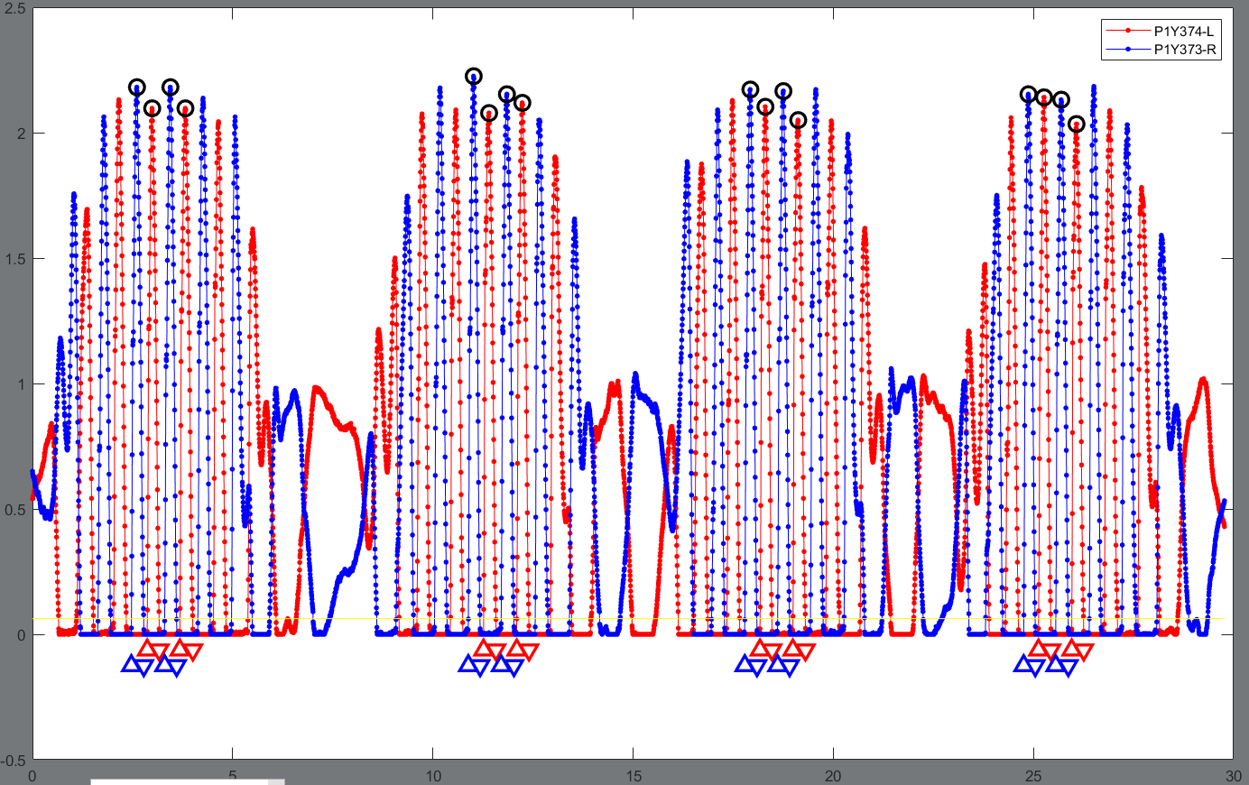

**Note:** For running (and walking), LAP computes the Average Loading Rate and peak Instantaneous Loading Rate (see Figure below) using previously published methods (Milner et al., Clinical Biomechanics, 2007).

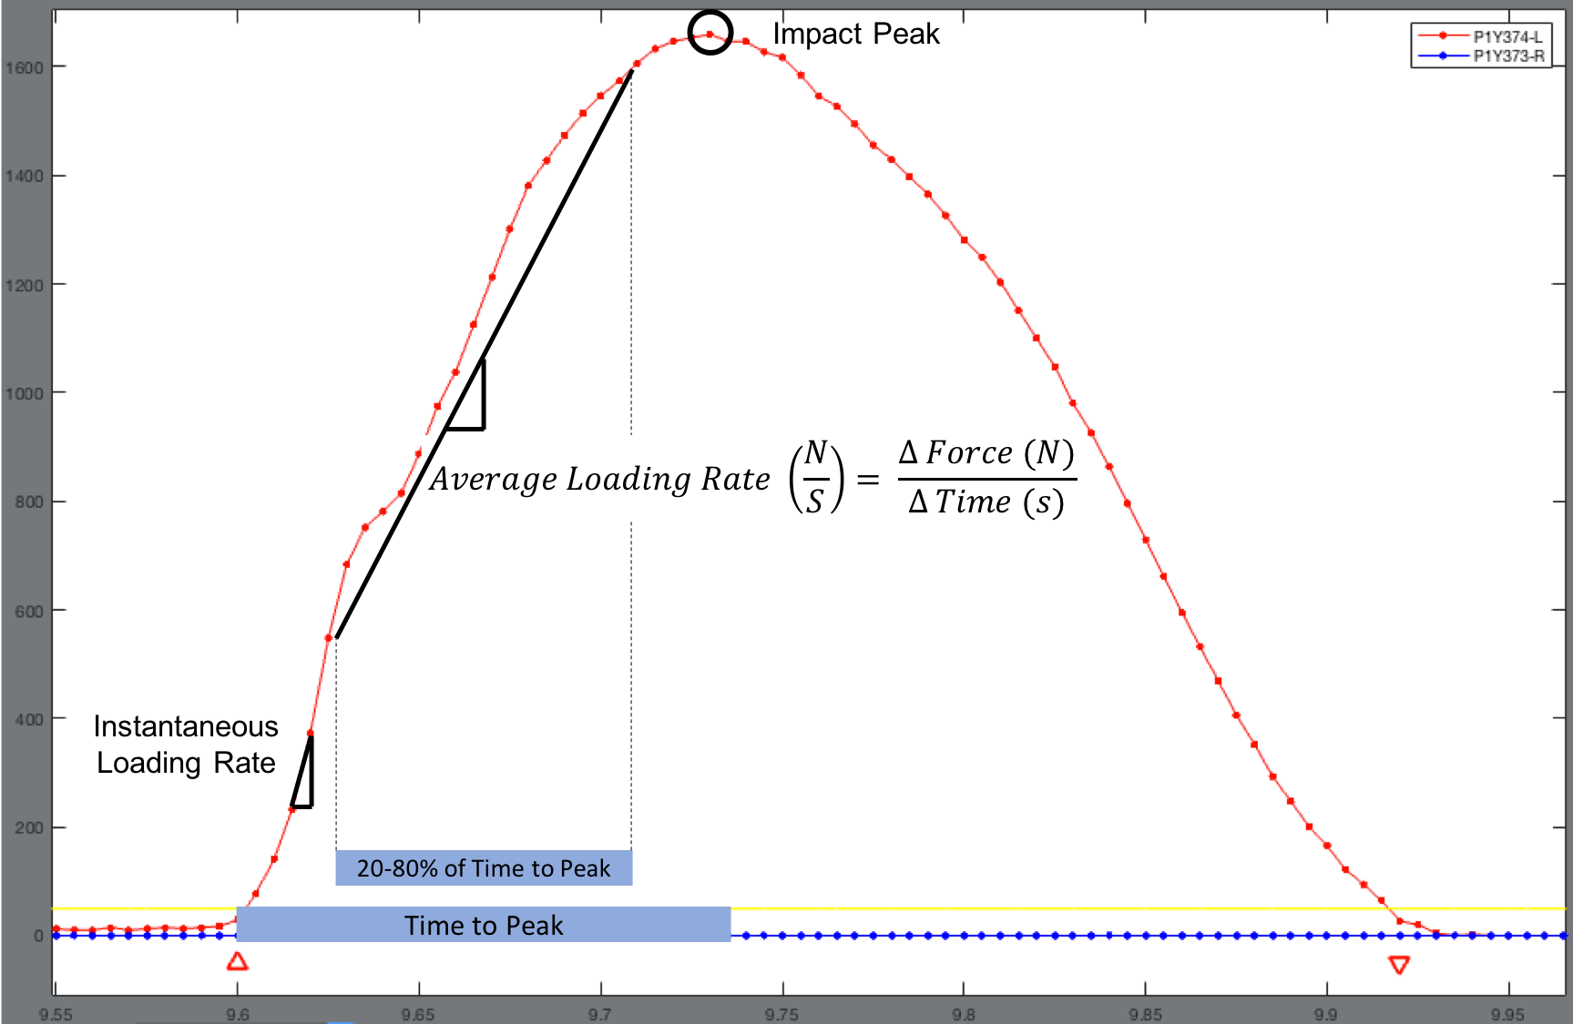

## **Walking**

For this example, a relatively uninjured participant (author ATP) walked overground at a comfortable pace, back and forth twice in a large room (four passes). We are going to analyze the middle two strides from each pass, where the participant should have reached a steady-state speed.

**Step 1:** Click “Load Data”, then navigate to and open the file named “walk_20-05-12 04-19-35-987”, select “Gait” from the drop-down menu, and enter the participants bodyweight (800 N).

**Step 2:** Zoom in on the entire first pass, and click “Delete Initial Contacts”. We are going to keep only the five strides in the middle of each pass (circled in green in Figure below), so click on every upward point arrow besides these ten. Click on “Delete Toe Offs” and click on all downward point arrows besides the ones circled. Click on “Delete Initial Contacts”.

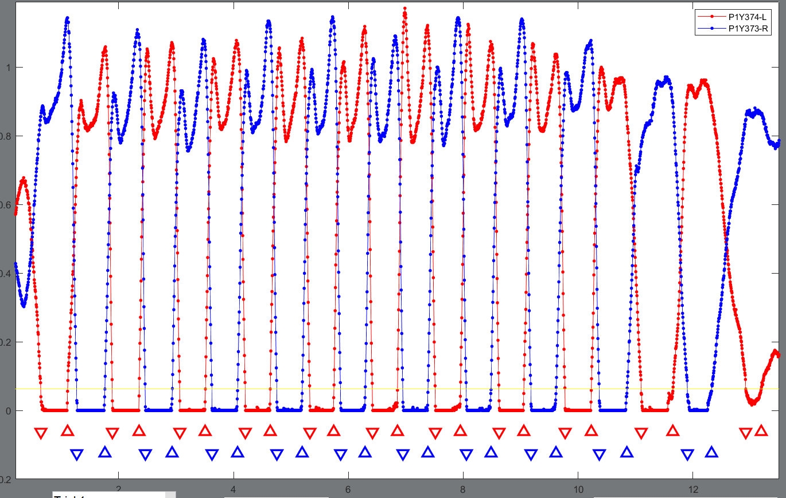

**Step 3:** Repeat Step 2 for the second, third, and fourth pass. After this step, there should be ten ground contact phases per pass, and your GUI axes should look like the Figure below (next page).

**Step 4:** Select the right foot as the dominant limb in the drop-down menu by selecting “P1Y373-R”.

**Step 5:** Set the percent ground contact sliders so that impulse and impact peak are set to 100%.

**Step 6:** Click the “Compute” button and save data in the desired location, workbook, and tab.

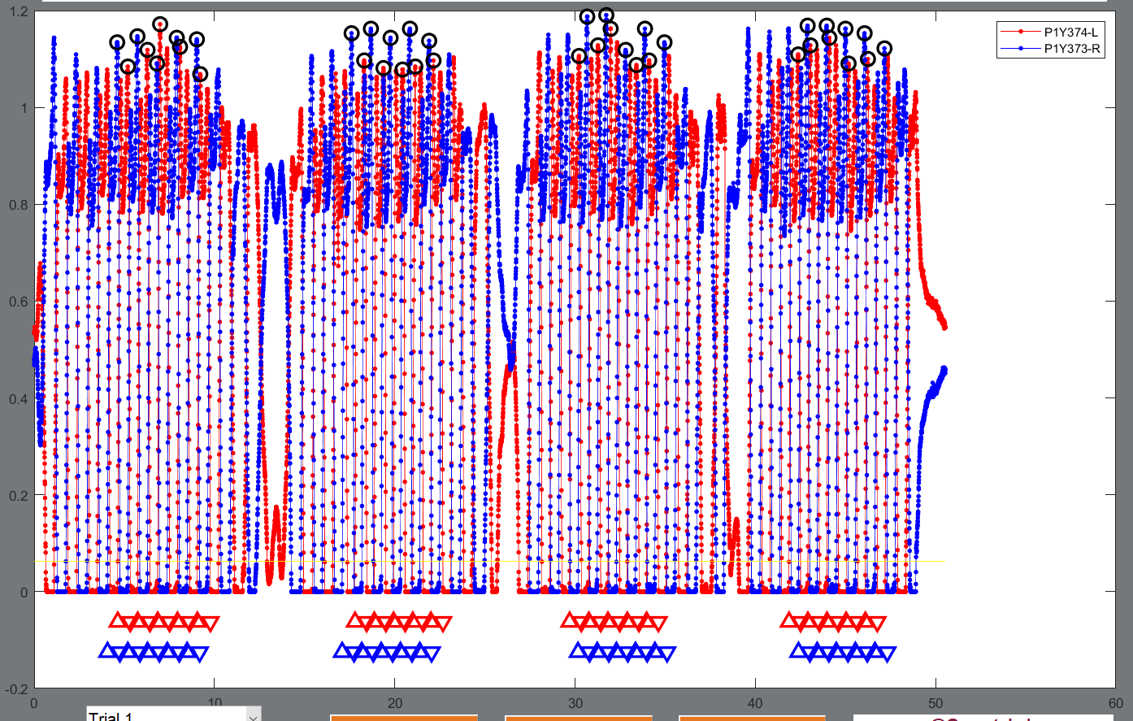

## **Squatting**

In this example, an uninjured participant completed 10 bilateral unweighted squats at a comfortable pace.

**Step 1:** Click “Load Data”, then navigate to and open the file named “squat_20-05-12 04-21-00-648”, select “Squatting” from the drop-down menu, and enter the participants bodyweight (800 N).

**Step 2:** For squatting, change the initial contact and toe off threshold to 700 N to zoom in on the plot (there are no initial contacts or toe offs for squatting).

**Step 3:** LAP will automatically identify the peak which occurs during the ascending phase of each squat for each limb (shown in figures below in black circles). After clicking compute, LAP gives you the chance to delete any misidentified peaks. In the message box, it will direct you to first “click on any misidentified peaks for P1Y374-L (red trace), or click after the end of the trial if no misidentified peaks”. In this example, there were no misidentified peaks, so click to the right of the plotted data once and then press enter (Figure below top). Next LAP will ask you to click on misidentified peaks for P1Y373-R (blue trace). There is one misidentified peak on the second repetition, click on it and then press enter (Figure below bottom).

